Changes made to the model: Customer Ordering
Observations from initial model:
From the initial version of the model, few observations were made regarding the impact of the average price of the commodities and the recognized delivery delay on the number of orders. Given that the customers are bound to respond to the supply-demand dynamic, and the observed delivery delay, the model needs to incorporate the effect of the two on the final number of the orders.
Adjusted List of Variables:
- Number of Sales Representatives
- Orders Per Rep
- Order Volume (Orders)
- Order Fill Rate
- Average Order Fill Rate
- Time to Average Order Fill Rate
- Order Backlog
- Capacity Per Month
- Percentage Utilisation
- Pressure on Production
- Actual Delivery Delay
- Recognised Delivery Delay
- Time to Recognise Delivery Delay
- Reduction in Orders
- Competitors’ Demand
- Average Price
- Reported Sales Revenue

Paired Variables:
- Number of Sales Representatives > Order Volume (+)
- Orders Per Rep > Order Volume (+)
- Order Volume > Percentage Utilisation (+)
- Percentage Utilisation > Capacity Per Month (-)
- Percentage Utilisation > Order Fill Rate (+)
- Capacity Per Month > Order Fill Rate (+)
- Order Fill Rate > Delivery Capacity (-)
- Delivery Capacity > Actual Delivery Delay (-)
- Actual Delivery Delay > Time to Recognise Delivery Delay (+)
- Time to Recognise Delivery Delay > Recognised Delivery Delay (+)
- Recognised Delivery Delay > Reduction in Orders (-)
- Reduction in Orders > Competitor’s Demand (+)
- Competitor’s Demand > Orders Per Rep (-)
- Orders Per Rep > Average Price (-)
The additional variables are Reduction in Orders and Competitors’ Demand.

Stock and Flow diagram for Customer Ordering
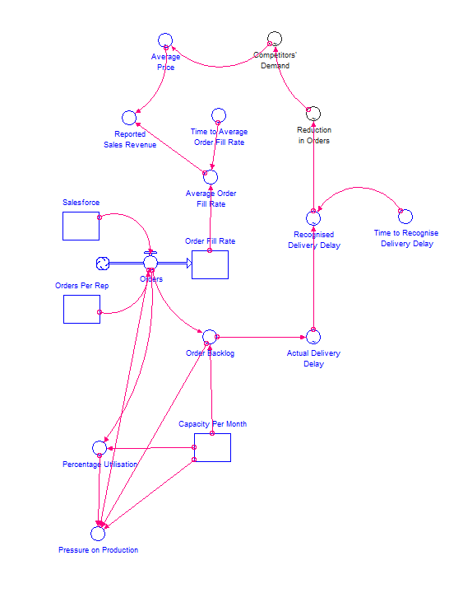
Policy Recommendation:
The goal of the adjustment is to include the effect of delays on the consumers’ decision making and the loss of market share due to inefficient practices within the company. As the company is accustomed to conservative policies that discourage capacity expansion, the company may

